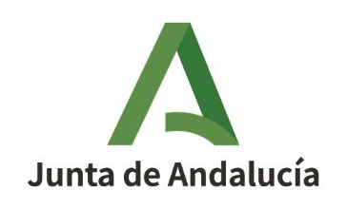
Consejería de Transformación Económica, Industria, Conocimiento y Universidades
Secretaría General de Universidades, Investigación y Tecnología

CURRICULUM VITAE (CVA)

IMPORTANT – The Curriculum Vitae cannot exceed 4 pages. Instructions to fill this document are available in the website.

Part A. PERSONAL INFORMATION
CV date

First name
Family name
Gender (*) |  | Birth date  (dd/mm/yyyy)
Social Security, Passport, ID number
e-mail |  | URL Web
Open Researcher and Contributor ID (ORCID) (*)
(*) Mandatory

A.1. Current position
Position
Initial date
Institution
Department/Center
Country |  |  | Teleph. number
Key words

A.2. Previous positions (research activity interuptions, art. 14.2.b))
Period | Position/Institution/Country/Interruption cause
xxxx-xxxx
yyyy-yyyy

A.3. Education

PhD, Licensed, Graduate | University/Country | Year

Part B. CV SUMMARY (max. 5000 characters, including spaces)

Part C. RELEVANT MERITS (sorted by typology)

C.1. Publications (see instructions)

C.2. Congress

C.3. Research projects

C.4. Contracts, technological or transfer merits

Calle Johannes Kepler, 1, Isla de la Cartuja. 41092- Sevilla
T: 955 06 39 10 https://juntadeandalucia.es/organismos/transformacion economicaindustriaconocimientoyuniversidades.html

